Contact: Jonina Costello / jcostello@full-throttlecom.com
Jason Bear / jbear@full-throttlecom.com
Phone: (805) 529-3700

GEAR KEEPER® SMALL TOOL, SUPER ZINGER AND PLIER RETRACTOR PRODUCTS
TOP MUST-HAVE LIST FOR FLY FISHING SEASON

The Original Retractable Devices for the Serious Outdoorsman

Never lose a piece of gear – ever, with Gear Keeper® retractable tether products. Stay focused on the important aspects of fly fishing this season, like perfecting your casting motion and loop formation, and not how to make sure you don’t misplace your pliers, clippers or knife. Renown as the highest quality retractors available, trust your gear is always there for you to grab and use when you need it. Then, let it go and know it will go back into place ready for its next use.

Just because it’s small, doesn’t mean it’s not an important piece of gear. Make sure to pick up a Gear Keeper Small Tools Retractor or two for your smallest tools like scissors or clippers. For larger gear, try the company’s Super Zinger Retractor designed with a Pin Mount connection on your vest. Allowing for full arm extension, and equipped with a ridiculously high break strength, you know this important piece of equipment won’t fail. Add the Gear Keeper Pliers Retractor which features a 360-degree rotating belt clip mounting system and you’ll have everything you need on your person and at the ready.

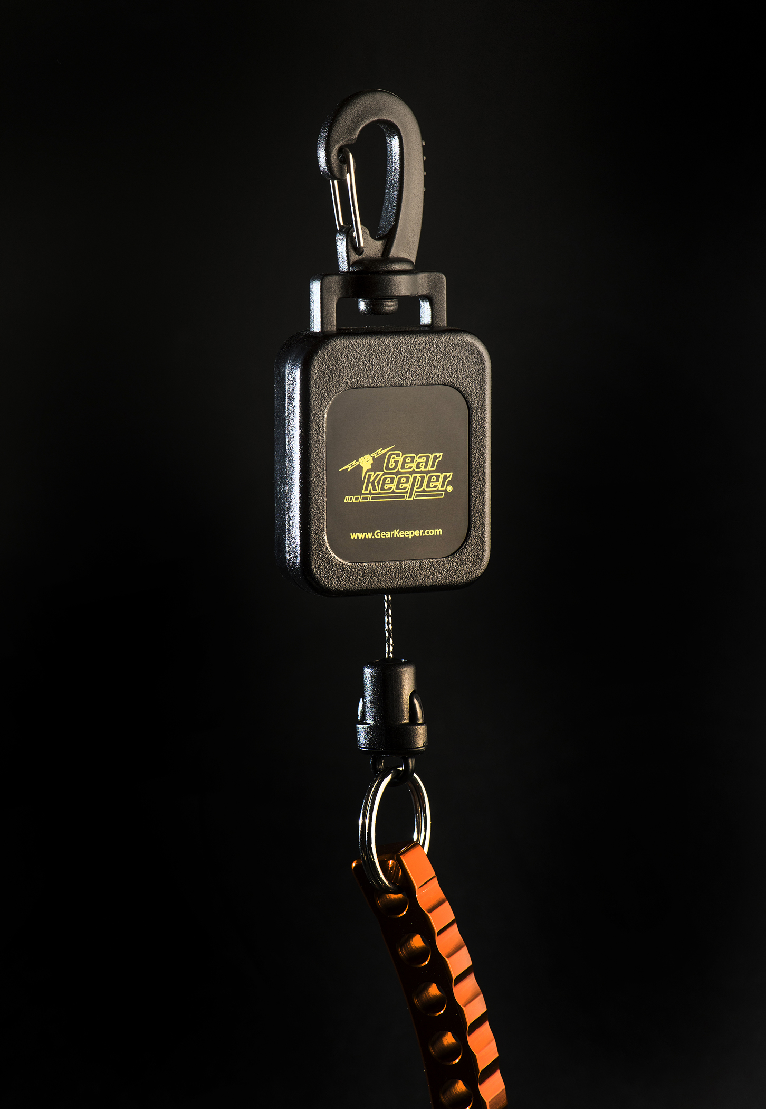
All Gear Keeper’s fly fishing retractor products have stainless steel components designed to last in water environments. Each incorporates the company’s patented flushing system that clears sand and debris from the unit. Built to be as functional as they are dependable, retractors feature the company’s patented Quick Connect (Q/C) system, which allows for quick and easy tool disconnection so you can swap your gear as needed. Streamlined and strong, the retractors integrate Spectra / Nylon coated stainless steel cable with the Super Zinger boasting a 40-lb. break strength, while the Small Tools Retractor and the Pliers Retractor have an impressive 60-lb. break strength. Finally, a high-impact casing means Gear Keeper Retractors can take repeated bumps and knocks.

The Gear Keeper Pliers Retractor utilizes a 360-degree rotating belt clip mounting system that allows the unit to pivot in any direction for ease of use and extended cable life. It attaches securely to belts or pants. The Super Zinger and Small Tools Retractor both offer Snap Clip or Pin Mount connections with a Spring Clip option also available with the Super Zinger Retractor.

The original Gear Keeper system was engineered specifically for SCUBA diving literally born out of a need to secure items in situations when hands are otherwise occupied. Gear Keeper systems are now available in more than 3,000 configuration options and used in applications from hunting, fishing and hiking to law enforcement, military and trucking.

For more information about the Gear Keeper Small Tools Retractor, Super Zinger or Pliers Retract, or other Gear Keeper Products contact Hammerhead Industries, Inc. at 1501 Goodyear Avenue, Ventura, CA 93003 • Phone: (805) 658-9922 • Fax: (805) 658-8833 • Or visit www.gearkeeper.com.

Visit the company on  for the latest product and company updates and a chance to win cool gear.
Editor’s Note: For hi-res images and releases, please visit our online Press Room at www.full-throttlecommunications.com

